Unit 8 Lesson 11: Comparing Groups

1 Notice and Wonder: Comparing Heights (Warm up)

Student Task Statement
What do you notice? What do you wonder?
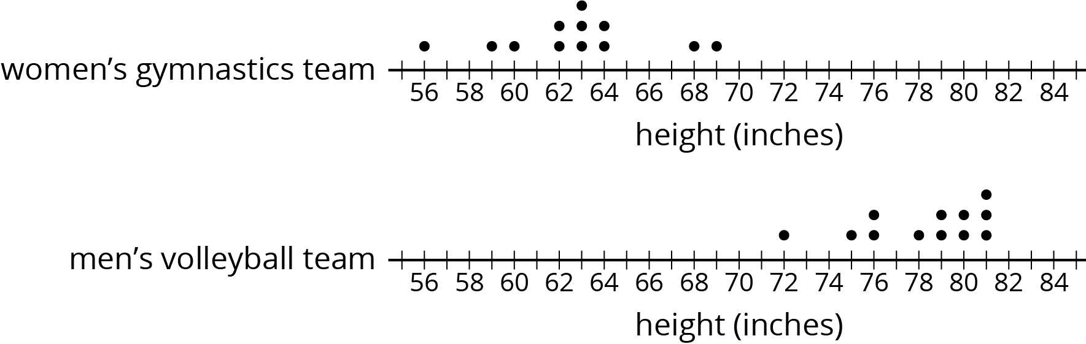

2 More Team Heights

Student Task Statement
- How much taller is the volleyball team than the gymnastics team?
  - Gymnastics team’s heights (in inches) : 56, 59, 60, 62, 62, 63, 63, 63, 64, 64, 68, 69
  - Volleyball team’s heights (in inches): 72, 75, 76, 76, 78, 79, 79, 80, 80, 81, 81, 81
- Make dot plots to compare the heights of the tennis and badminton teams.
  - Tennis team’s heights (in inches): 66, 67, 69, 70, 71, 73, 73, 74, 75, 75, 76
  - Badminton team’s heights (in inches): 62, 62, 65, 66, 68, 71, 73
- What do you notice about your dot plots?
- Elena says the members of the tennis team were taller than the badminton team. Lin disagrees. Do you agree with either of them? Explain or show your reasoning.

3 Family Heights

Student Task Statement
Compare the heights of these two families. Explain or show your reasoning.
- The heights (in inches) of Noah’s family members: 28, 39, 41, 52, 63, 66, 71
- The heights (in inches) of Jada’s family members: 49, 60, 68, 70, 71, 73, 77

4 Track Length (Optional)

Student Task Statement
Here are three dot plots that represent the lengths, in minutes, of songs on different albums.
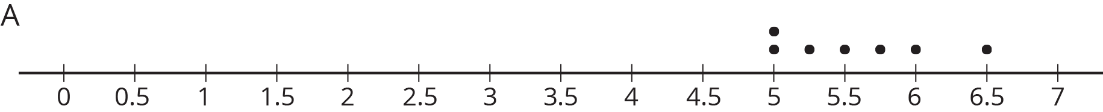

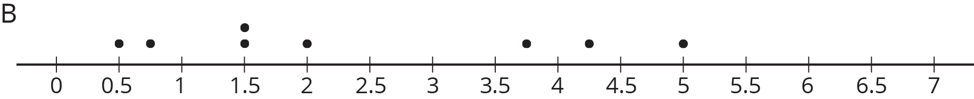

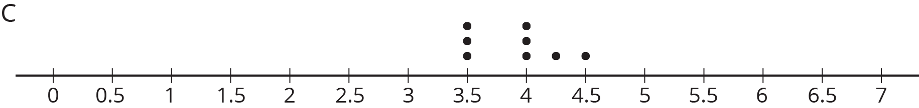
- One of these data sets has a mean of 5.57 minutes and another has a mean of 3.91 minutes.
  - Which dot plot shows each of these data sets?
  - Calculate the mean for the data set on the other dot plot.
- One of these data sets has a mean absolute deviation of 0.30 and another has a MAD of 0.44.
  - Which dot plot shows each of these data sets?
  - Calculate the MAD for the other data set.
- Do you think the three groups are very different or not? Be prepared to explain your reasoning.
- A fourth album has a mean length of 8 minutes with a mean absolute deviation of 1.2. Is this data set very different from each of the others?

Activity Synthesis
© CC BY Open Up Resources. Adaptations CC BY IM.

