Lesson 13: Intersection Points
- Let’s look at how circles and parabolas interact with lines.

13.1: Which One Doesn’t Belong: Lines and Curves
Which one doesn’t belong?

A
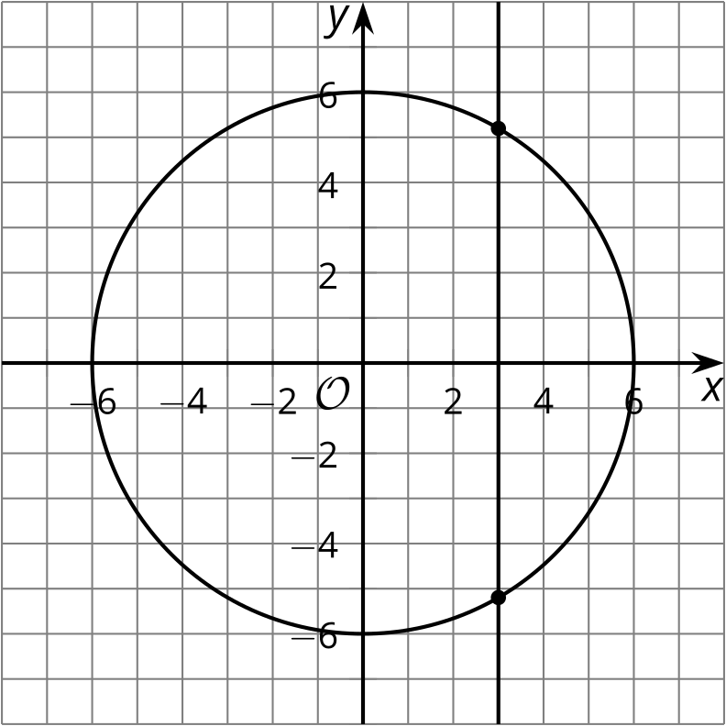

B
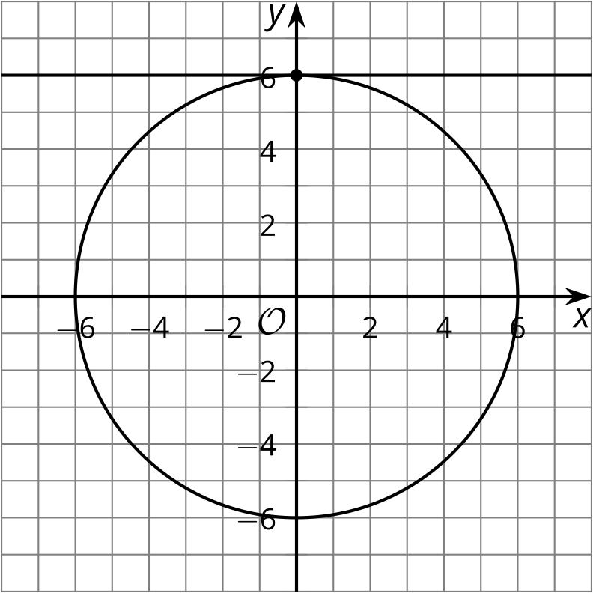

C
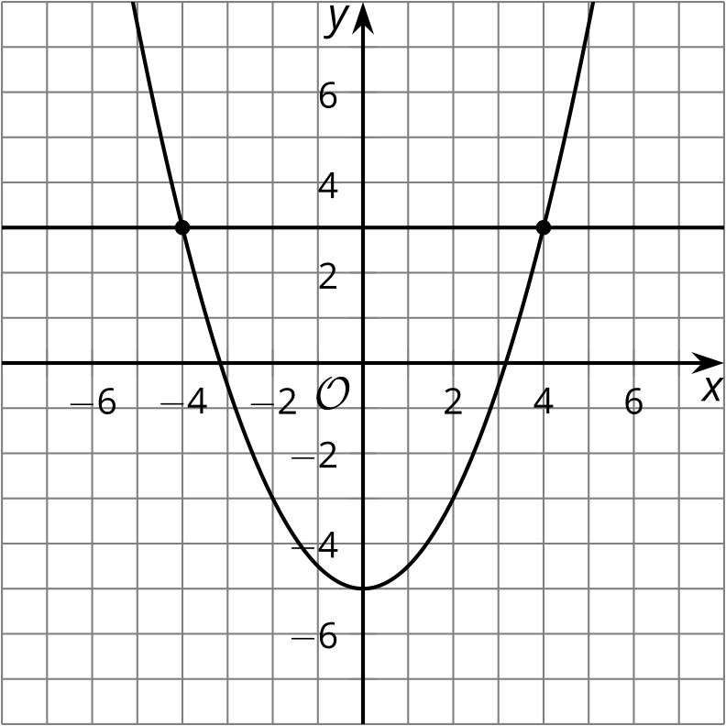

D
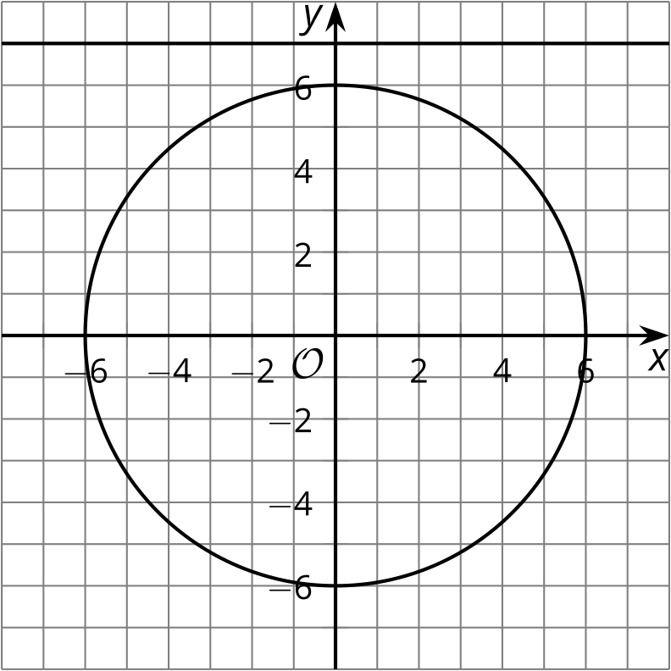

13.2: Circles and Lines
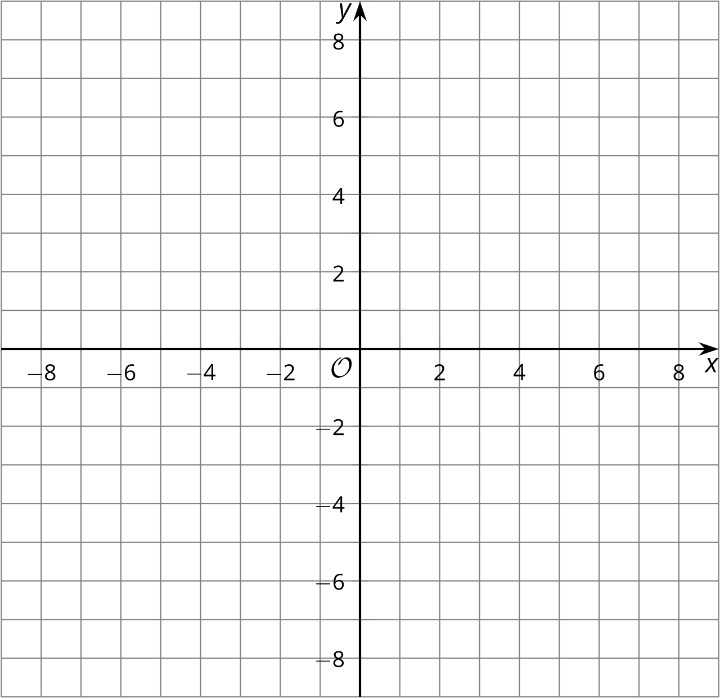
- The equation ${\left(x−3\right)}^{2}+{\left(y−2\right)}^{2}=25$ represents a circle. Graph this circle on the coordinate grid.
- Graph the line $y=6$. At what points does this line appear to intersect the circle?
- How can you verify that the 2 figures really intersect at these points? Carry out whatever procedure you decide.
- Graph the line $y=x−2$. At what points does this line appear to intersect the circle? Verify that the 2 figures really do intersect at these points.

13.3: Creating Lines
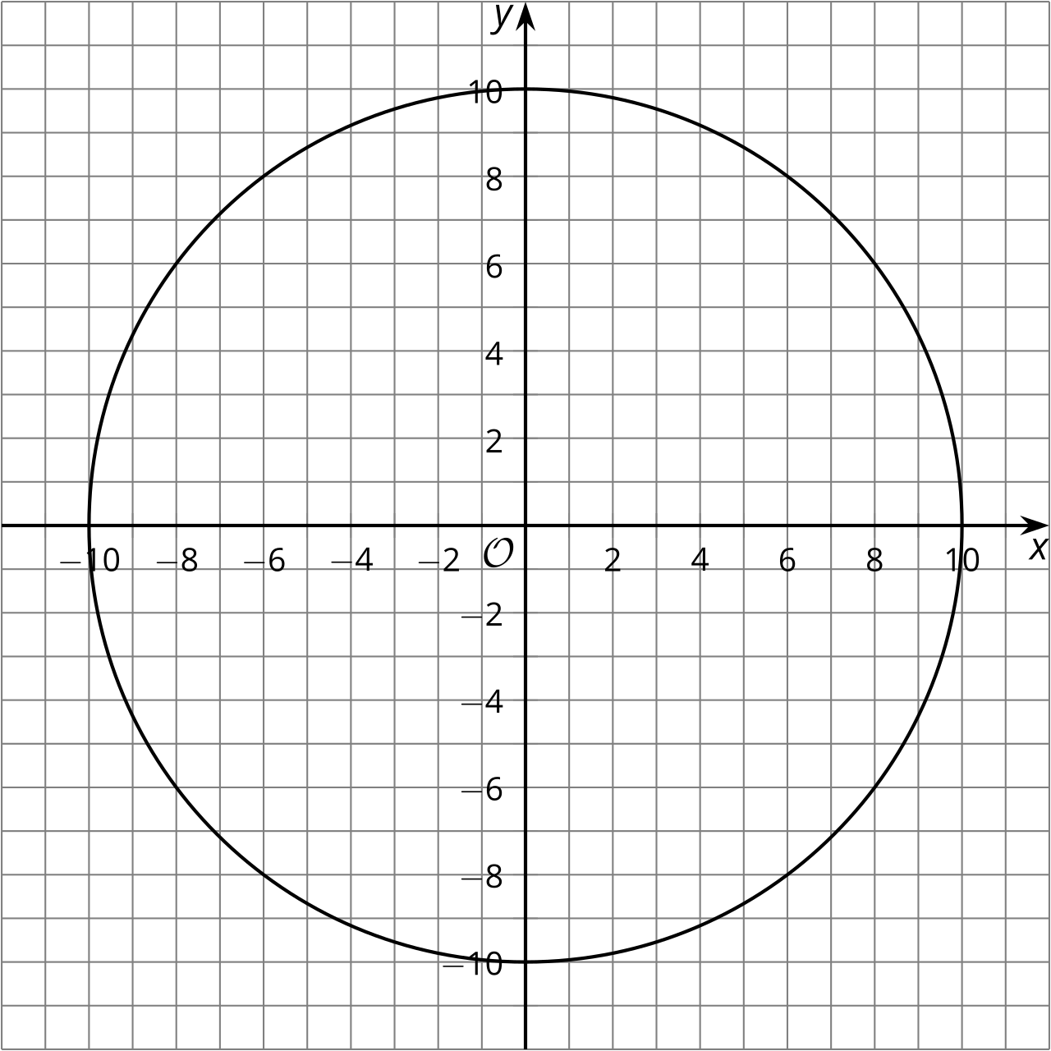
- Write an equation representing the circle in the graph.
- Graph and write equations for each line described:
  - any line parallel to the $x$-axis that intersects the circle at 2 points
  - any line perpendicular to the $x$-axis that doesn’t intersect the circle
  - the line perpendicular to $y=\text{-}\frac{1}{3}x+5$ that intersects the circle at $\left(6,8\right)$
- For the last line you graphed, find the second point where the line intersects the circle. Explain or show your reasoning.

Are you ready for more?
- Graph the equations $y−3={\left(x−2\right)}^{2}$ and $y−4=2\left(x−3\right)$ and find their point of intersection.
- Show that the graph of $y−3={\left(x−2\right)}^{2}$ and $y−4=m\left(x−3\right)$ intersect at the point $\left(m+1,m^{2}−2m+4\right)$.

Lesson 13 Summary
We can graph circles and lines on the same coordinate grid and estimate where they intersect. The image shows the circle ${\left(x−10\right)}^{2}+{\left(y+6\right)}^{2}=169$ and the line $y=x−23$. The 2 figures appear to intersect at the points $\left(22,\text{-}1\right)$ and $\left(5,\text{-}18\right)$. To verify whether these truly are intersection points, we can check if substituting them into each equation produces true statements.
Let’s test $\left(22,\text{-}1\right)$. First, substitute it into the equation for the line. When we do so, we get $\text{-}1=22−23$. This is a true statement, so this point is on the line.
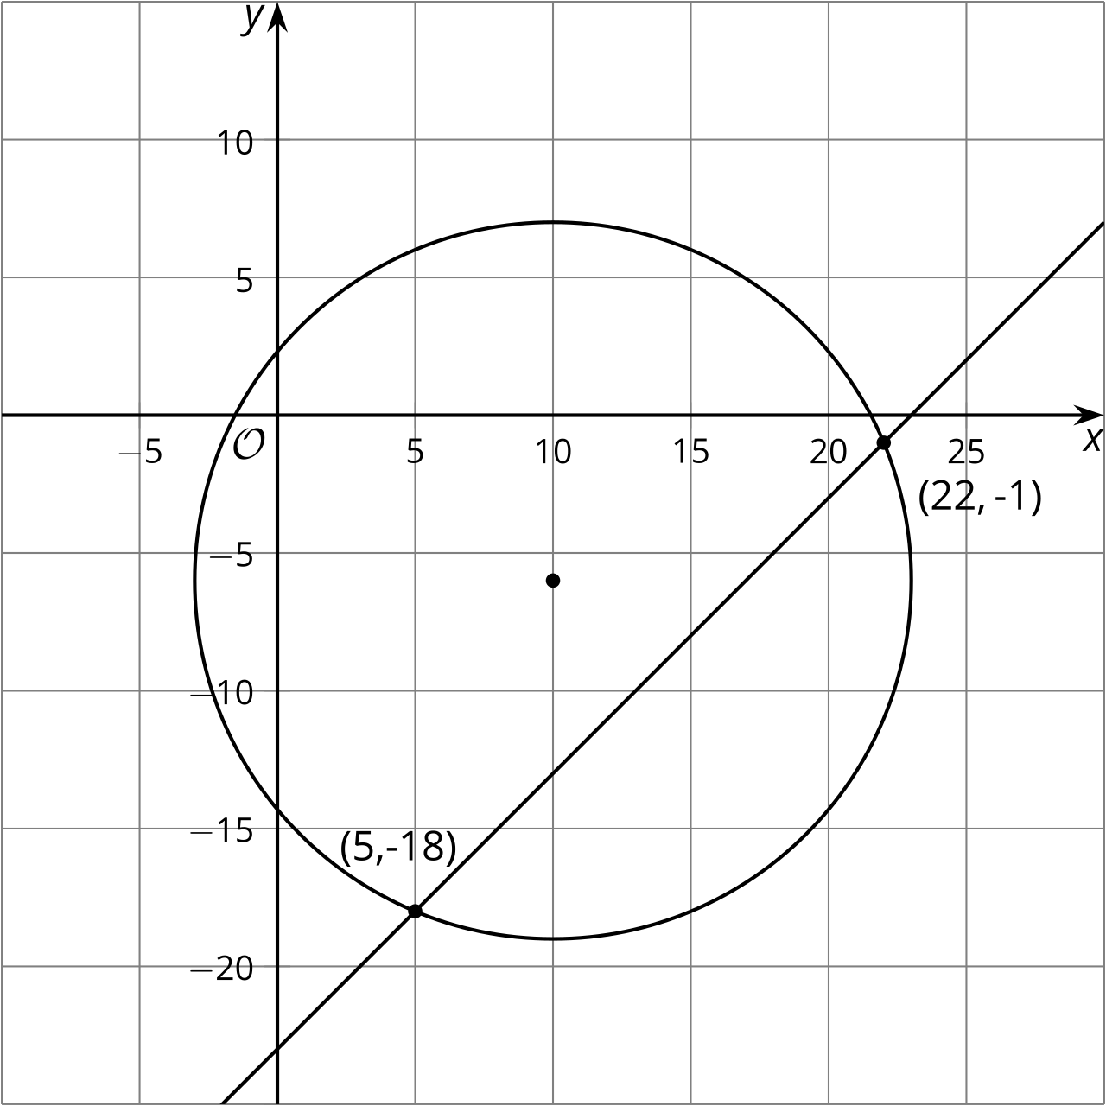
Next, substitute it into the equation for the circle. This is the same as checking to see if the distance from the point to the center is $\sqrt{169}$, or 13 units. We get ${\left(22−10\right)}^{2}+{\left(\text{-}1−\left(\text{-}6\right)\right)}^{2}=169$. Evaluate the left side to get $144+25=169$. This is a true statement, so the point $\left(22,\text{-}1\right)$ is on the circle. It’s on both the circle and the line, so it must be an intersection point for the 2 figures.
© CC BY 2019 by Illustrative Mathematics®

