Unit 2 Lesson 10: Practicing Proofs

1 Brace Yourself! (Warm up)

Images for Launch
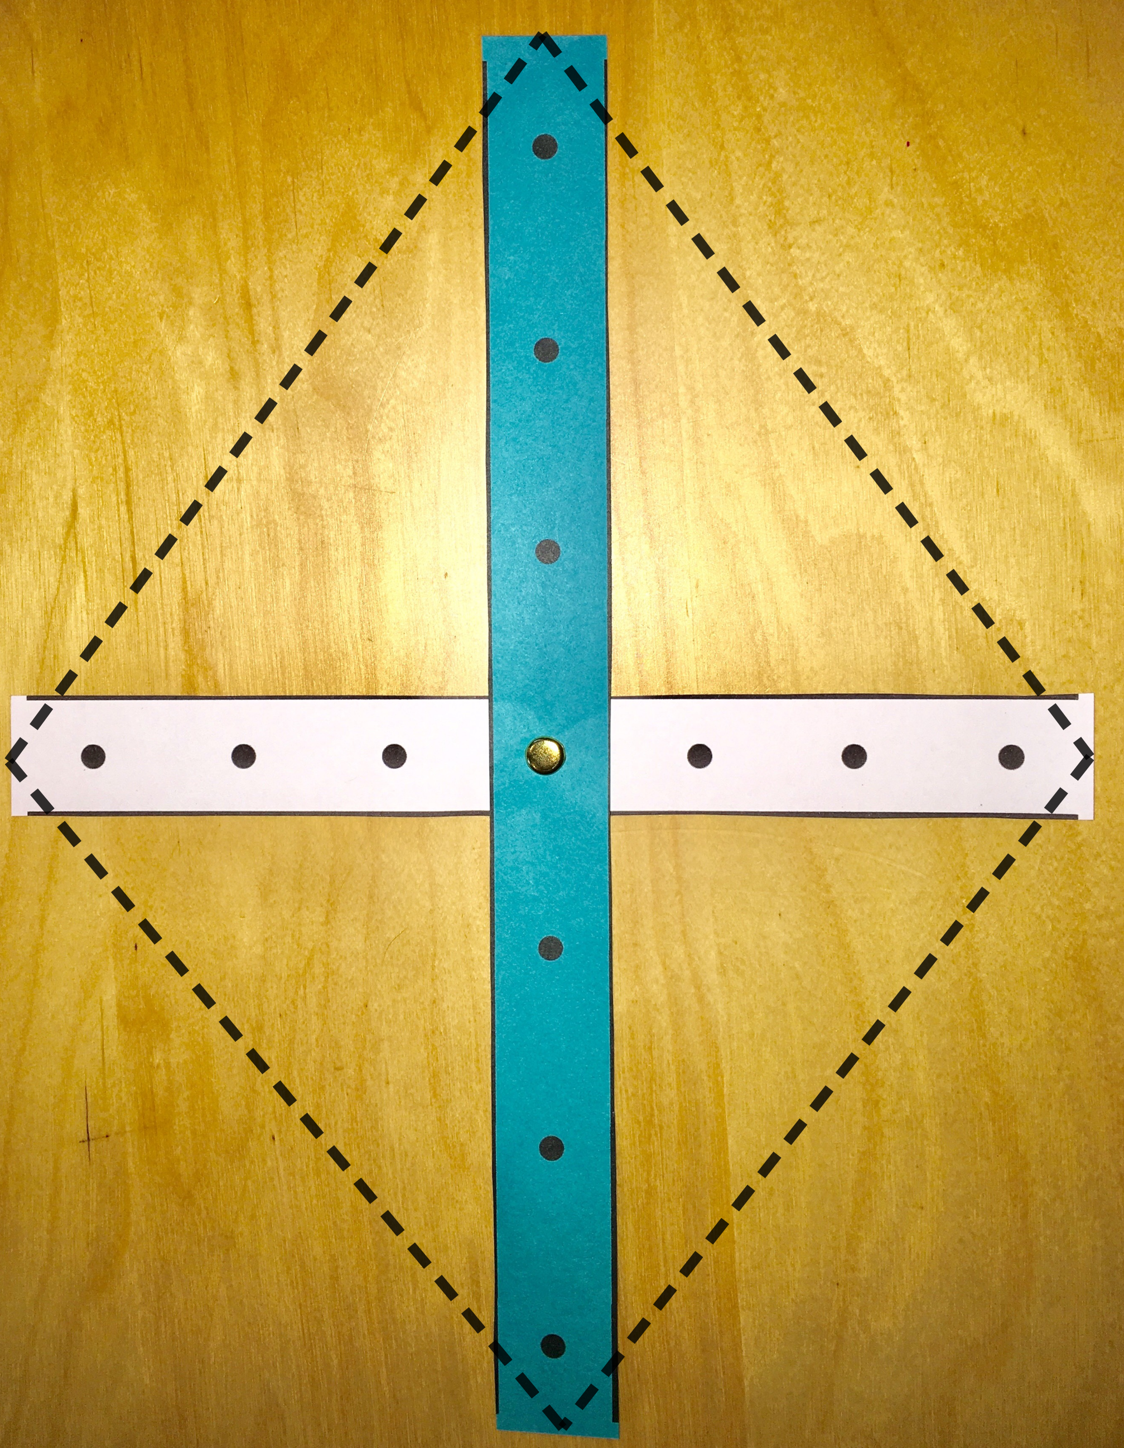

Student Task Statement
What can you do with the braces and fasteners your teacher will give you?
What different ways can you arrange them?
What different quadrilaterals can you make by changing the braces?
Keep track of your findings.

2 Card Sort: More Practice Seeing Shortcuts

Student Task Statement
- Your teacher will give you a set of cards that show different structures. Sort the cards into 2 categories of your choosing. Be prepared to explain the meaning of your categories. Then, sort the cards into 2 categories in a different way. Be prepared to explain the meaning of your new categories.
- Sort the cards by rigid vs. flexible structures.
- State at least one set of triangles that can be proved congruent using:
  - Side-Angle-Side Triangle Congruence Theorem
  - Angle-Side-Angle Triangle Congruence Theorem
  - Side-Side-Side Triangle Congruence Theorem

3 Matching Pictures to Proofs

Student Task Statement
Take turns with your partner to match a statement with a diagram that could go with that proof. For each match you find, explain to your partner how you know it’s a match. For each match your partner finds, listen carefully to their explanation. If you disagree, discuss your thinking and work to reach an agreement.
- A quadrilateral with perpendicular diagonals that bisect each other is equilateral.
- If one diagonal of a quadrilateral is the perpendicular bisector of the other, then 2 pairs of adjacent sides are congruent.
- Opposite angles in an equilateral quadrilateral are congruent.
- In a parallelogram, opposite sides are congruent.
© CC BY 2019 by Illustrative Mathematics®

